**Examination Question Bank**

Answers (with explanations) to selected questions to be sent in followup. In the interest of conserving resources, multiple choices questions may be compacted.

1. Which of these is NOT a vesicle that comes off the Golgi?
   1. regulated secretory vesicle
   2. constitutive secretory vesicle
   3. phagosome
   4. lysosome
   5. None of the above
2. A coated pit is a feature of which of these processes?
   1. phagocytosis
   2. pinocytosis
   3. receptor-mediated endocytosis
   4. both (a) and (b)
   5. all of the above
3. A neutrophil engulfs a bacterium by which process?
   1. receptor-mediated endocytosis
   2. exocytosis
   3. phagocytosis
   4. pinocytosis
   5. secreted vesicles
4. Glycolysis is a pathway that starts with which of these biomolecules?
   1. fructose (b) acetyl-CoA (c) pyruvate (d) glucose (e) lactate
5. Glycolysis is a pathway that ends with which of these biomolecules?
   1. carbon dioxide (CO2) (b) acetyl-CoA (c) pyruvate (d) glucose (e) lactate
6. Which of these is not an organelle?
   1. mitochondria (b) nucleus (c) endoplasmic reticulum (d) Golgi apparatus  
      (e) none of the above: they are all of the above are organelles
7. Which of the features below is not part of the smooth endoplasmic reticulum (smooth ER)?
8. ribosomes (b) a phospholipid bilayer membrane (c) lumen (d) cisternae

(e) cytochrome P450 enzymes

1. The electron transport system occurs where?

(a) mitochondrial inner membrane (b) mitochondrial intermembrane space   
(c) mitochondrial matrix (d) cytosol (e) peroxisome

1. In meiosis, in which phase does homologous recombination and the exchange of maternal and paternal DNA (chromosomal crossover)?
   1. prophase I (b) telophase I (c) prometaphase I (d) prometaphase II (e) prophase II
2. In meiosis, in which phase does homologous recombination and the exchange of maternal and paternal DNA (chromosomal crossover)?
   1. prophase I (b) telophase I (c) prometaphase I (d) prometaphase II (e) prophase II
3. Which of these is not found in RNA?

(a) adenine (A) (b) thymine (T) (c) uracil (U) (d) guanine (G) (e) cytosine (C)

1. Which of these is not found in DNA?

(a) 2’-deoxyribose (A) (b) thymine (T) (c) phosphate (d) ribose (e) adenine (A)

1. This structure for coiling DNA takes 6 nucleosomes and forms a coil from them?

(a) nucleosomal chromatid (b) solenoid (c) exon (d) intron (e) nuclear pore

1. Which of these is a FALSE statement?
   1. all protein synthesis happens outside of the nucleus
   2. integral proteins of the plasma membrane are synthesized in the rough ER
   3. the nuclear envelope is continuous with the peroxisomal membrane
   4. all nuclear proteins must be imported through the nuclear pore from cytosol into nucleus
   5. ribosomes dock with the rough ER membrane
2. This class of RNA bonds to the amino acid that is used for translation elongation
   1. messenger RNA (mRNA) (b) transfer RNA (tRNA) (c) ribosomal RNA (rRNA)  
      (d) there is no such RNA (e) the class of RNA exists but not listed
3. This enzyme joins gaps between phosphate and ribose sugar in the DNA strand that may exist after DNA replication or repair
   1. RNA polymerase II (b) RNA primase (c) DNA polymerase III   
      (d) DNA polymerase I (e) DNA ligase
4. The location on the chromosome where a gene is found is called
   1. haploid (b) diploid (c) locus (d) allele (e) centromere
5. In mitosis, these microtubules extending from the aster cause the spindle poles to be pushed further part
   1. chromosomal microtubules (b) polar microtubules (c) astral microtubules  
      (d) all of the above (e) none of the above
6. The onset of the alignment of chromosomes on the spindle equator signals what phase of mitosis?
   1. prophase (b) prometaphase (c) metaphase (d) anaphase (e) telophase
7. This enzyme make DNA strands but cannot remove RNA primers during DNA replication?
   1. RNA polymerase II (b) RNA primase (c) DNA polymerase III   
      (d) DNA polymerase I (e) DNA ligase
8. This term refers to a complete copy of the genetic information of the genetic information of an organism
   1. chromosome (b) chromatid (c) nucleosome (d) genome (e) allele
9. The set of chromosomes in gametes are described as what? (Gametes are _____ cells)
   1. haploid (b) diploid (c) fertilization (d) genome (e) allele
10. What kind of chemical bond is responsible for base pairing in creating double stranded DNA?
    1. polar covalent (b) covalent (c) ionic (d) hydrogen bond (e) van der Waals
11. Which of these is a coupled active transport process?
    1. H2O movement through aquaporin (b) Na/K ATPase activity   
       (c) transport of glucose using Na+ ion concentration difference  
       (d) pumping Ca back into sarcoplasmic reticulum with ATPase (e) all of the above
12. This cell junction would be found between cells that need to stop paracellular transport pathways
    1. desmosome (b) tight junction (c) gap junction (d) adherens junction (e) none of the above
13. What is the term that refers to the many different variations in the sequence of DNA that expresses a trait corresponding to a gene?
    1. haploid (b) diploid (c) chromosome (d) genome (e) allele
14. Knowing that a codon is a triplet of bases (3 bases), how many possible codons are there in the genetic code?
    1. 2 (b) 16 (c) 20 (d) 64 (e) 12,500
15. Which of these is NOT found as a feature of (contained in or part of) the nucleus?
    1. nuclear envelope (b) nucleolus (c) chromatin (d) Golgi   
       (e) pre-messenger RNA (pre-mRNA)
16. This structure for coiling DNA uses 8 highly basic (positively charged) polypeptides?

(a) nucleosome (b) solenoid (c) exon (d) intron (e) nuclear pore

1. Which of these is a factor determining the melting temperature (Tm) of a double-stranded DNA oligonucleotide?

(a) number of exons (b) number of introns (c) number and proportion of GC and AT pairs  
(d) number of nuclear pores (e) Golgi processing

1. What is the term that corresponds to a genotype having the same alleles, such as *BB*?
   1. haploid (b) diploid (c) nuclear (d) homozygous (e) heterozygous
2. The onset of the breakdown of the nuclear envelope signals what phase of mitosis?
   1. prophase (b) prometaphase (c) metaphase (d) anaphase (e) telophase
3. Which of these involves GTP binding to a protein subunit?
   1. receptor tyrosine kinase activation by growth factor ligands
   2. G protein-coupled receptor activation
   3. steroid hormone receptor activation
   4. both (a) and (b)
   5. all of the above
4. This enzyme is required for transcription of messenger RNA (mRNA)
   1. RNA polymerase II (b) RNA primase (c) DNA polymerase III   
      (d) DNA polymerase I (e) DNA ligase
5. One turn of the TCA cycle produces how many carbon dioxide (CO2) molecules?
   1. 0 (b) 1 (c) 2 (d) 3 (e) 6
6. What is catabolism and anabolism?
7. From one glucose molecule, fill in the table below. Note that “ATP or GTP” can be substrate level phosphorylation for glycolysis and TCA, and oxidative phosphorylation level for ETS

|  |  |  |  |
| --- | --- | --- | --- |
| Produced | Glycolysis | TCA (Krebs) Cycle | Electron Transport System |
| NADH |  |  |  |
| FADH2 |  |  |  |
| ATP or GTP |  |  |  |
| CO2 |  |  |  |

1. What type of cell in the bone forms bone and is reduced in osteoporosis?
2. What is the name of the proteoglycan found in abundance in the intervertebral disc?
3. Translational elongation repeats 3 steps: (1) Decoding (2) Transpeptidation and (3) Translocation. Briefly describe what happens in all three steps. Your answer should include mention of the sites in the ribosome (P, E, A) and how tRNA and mRNA are involved.  
     
   (1) Decoding  
     
     
   (2) Transpeptidation  
     
     
   (3) Translocation
4. 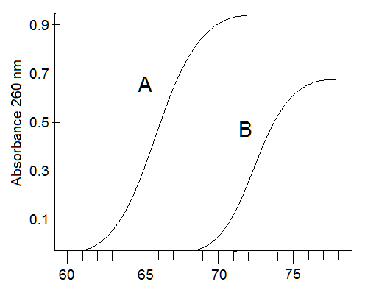The following are related to the figure at right

(a) Estimate the melting temperature (Tm) of ds DNA oligonucleotide A ____ (hint: draw lines on the graph to show your thought process)

* 1. Estimate Tm for oligo B ______
  2. If both oligos have the same number of base pairs, which oligonucleotide has the higher %AT content?

Yes, another factor affecting the Tm is the number of base pairs: if two oligos have the same %GC-%AT content. the longer oligo, i.e. has more base pair counts, will have a higher Tm.

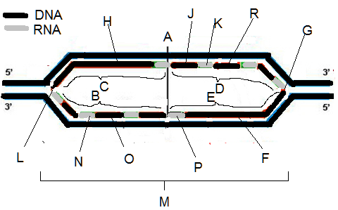A scientist is designing oligonucleotides for a PCR-based diagnostic test for cancer

There may be several possibilities for answers below in the diagram above. You only need enter one answer.

1. ___ newly made DNA
2. ___ RNA primer
3. ___ replication bubble
4. ___ replication fork
5. ___ leading strand
6. ___ lagging strand
7. ___ replication origin

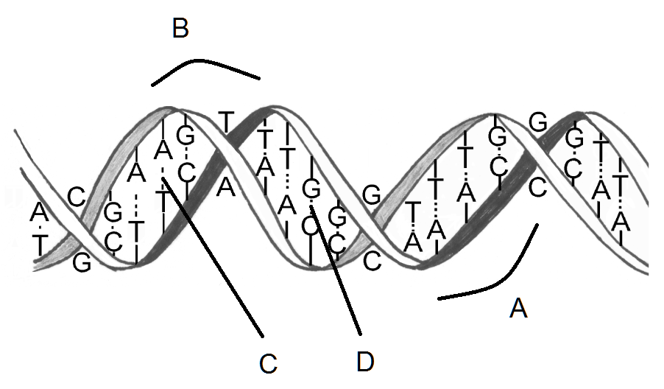In the figure at right, you see the double stranded DNA helix  
  
What is the spacing shown by A called?  
  
What is the spacing shown by B called?  
  
What are the number of bonds between the GC base pair shown in D?  
  
What are the number of bonds between the AT base pair shown in C?  
  
What is the name of the type of DNA that has the classical right-handed helical twist?  
  
What is the name of the type of DNA that has a zig-zag left-handed twist and is thought to be a transcriptionally inactive form?

1. Which of these is the name for the process in which RNA is made?
   1. replication
   2. recombination
   3. transcription
   4. translation
   5. none of the above
2. A ribosome would be used in which of these processes?
   1. replication
   2. recombination
   3. transcription
   4. translation
   5. none of the above
3. Which of these is NOT required for translation?
   1. m7G-cap on 5’ end of mRNA
   2. poly(A) tail on 3’ end of mRNA
   3. 40S ribosomal subunit
   4. AUG codon
   5. all of the above are required
4. Which of these is a DNA sequence that is used to locate the start of transcription?
   1. transcription factor
   2. m7G 5’ cap on mRNA
   3. promoter
   4. exon
   5. intron
5. Which of these is a protein?
   1. transcription factor
   2. m7G 5’ cap on mRNA
   3. promoter
   4. exon
   5. intron
6. The scanning of the 40S ribosome complexed protein factors and with tRNAMet to an AUG code is involved in what process?
   1. transcription initiation
   2. translation termination
   3. translation initiation
   4. transcription termination
   5. translation elongation
7. A release factor called eRF1 enters the A site of a ribosome and hydrolyzes the nascent polypeptide in what process?
   1. transcription initiation
   2. translation termination
   3. translation initiation
   4. transcription termination
   5. translation elongation
8. The exons in a gene have 30% C. Which of the following below is true about the mature mRNA?
   1. it will be 20% G
   2. it will be 30% A
   3. it will be 20% U
   4. it will be 30% T
   5. cannot be determined from the information given
9. Which of these is a TRUE statement?
   1. DNA is synthesized in the 5’🡪3’ direction
   2. RNA is synthesized in the 5’🡪3’ direction
   3. In some cases RNA is synthesized in the 3’🡪5’ direction
   4. (a) and (b)
   5. all of the above are true
10. Where will you find Coenzyme Q?
    1. as an electron carrier in TCA cycle
    2. used in a reaction with glucose in glycolysis
    3. as a cofactor in the pyruvate dehydrogenase reaction forming its 2-carbon product
    4. involved with interacting with RNA polymerase in transcription
    5. none of the above
11. Where will you find Coenzyme A?
    1. as an electron carrier in TCA cycle
    2. used in a reaction with glucose in glycolysis
    3. as a cofactor in the pyruvate dehydrogenase reaction forming its 2-carbon product
    4. as an oxidation-reduction component in the electron transport system (ETS)
    5. none of the above
12. The space within the endoplasmic reticulum is called the
    1. lumen (b) pore (c) cisternae (d) cytosol (e) vesicle interior
13. The Golgi apparatus is made up of a stack of enclosed flattened membranous sacs called
    1. lumen (b) pore (c) cisternae (d) cytosol (e) vesicle interior
14. Which of these integral membrane proteins would be crucial to producing a neuronal resting membrane voltage potential?
    1. Na+/glucose symporter (b) sarcoplasmic reticulum Ca-ATPase (c) Na+/K+ ATPase  
       (d) protein kinase A (e) G-alpha (G) subunit
15. Which of these integral membrane proteins is used to transport Ca2+ out of a muscle cell to stop its contraction?
    1. Na+/glucose symporter (b) sarcoplasmic reticulum Ca-ATPase (c) Na+/K+ ATPase  
       (d) protein kinase A (e) G-alpha (G) subunit
16. Which of these proteins is involved in signal transduction and phosphorylates other proteins?
    1. Na+/glucose symporter (b) sarcoplasmic reticulum Ca-ATPase (c) Na+/K+ ATPase  
       (d) protein kinase A (e) G-alpha (G) subunit
17. You observe a cell under high magnification of a phase-contrast microscope forming a cupped invagination with no pseudopodia and form an internalized vesicle?
    1. regulated secretory exocytosis (b) constitutive secretory exocytosis (c) pinocytosis  
       (d) phagocytosis (e) exocytosis
18. A glycoprotein will get a sulfate (SO42–) group on its glycan (oligosaccharide) sugar portion: where will this happen?
    1. plasma membrane (b) mitochondria (c) Golgi apparatus   
       (d) rough endoplasmic reticulum (e) peroxisome
19. A lysosome fused with a phagocytic vesicle. Which of these is FALSE?
    1. the lysosome contain proteins and other molecules that have digestive properties or chemical reactions that break down what is in the phagocytic vesicle
    2. the pH within the vesicle will increase
    3. the resulting vesicle has membrane protein transporters that are proton (H+) ATPases and will move H+ from the cytosol into the vesicle
    4. both (a) and (b)
    5. none of the above: all of the above are true
20. Which of these is NOT an example of receptor-mediated endocytosis?
    1. diphtheria bacteria exploiting this process to make cells take up their toxin
    2. the cell bringing in glucose for glycolysis
    3. LDL receptors taking in LDL particles to obtain cholesterol
    4. cells importing vital iron ion (Fe3+)
    5. all of the above are example of receptor-mediated endocytosis
21. This has its own DNA, which is small and circular
    1. plasma membrane (b) mitochondria (c) Golgi apparatus   
       (d) rough endoplasmic reticulum (e) peroxisome
22. Catalase is an enzyme that does what?
    1. it corrects problems in DNA
    2. it removes a potentially dangerously reactive chemical called superoxide anion (O2–)
    3. it removes a potentially dangerously reactive chemical called hydrogen peroxide (H2O2)
    4. it is one of components of electron transport system that moves protons (H+) across inner membrane
    5. It uses 3 protons (H+) to create one ATP molecule in the mitochondria
23. Exocytosis involves a very important substance entering the cytosol from the extracellular medium to activate proteins involved in fusing the membrane of vesicles to the plasma membrane: what is that?
    1. glucose
    2. phosphate ion (Pi)
    3. calcium ion (Ca2+)
    4. sodium ion (Na+)
    5. potassium (K+)
24. Which of these chemical bonds is a result of one atom having a fully positive charge and the other atom having a fully negative charge?
    1. ionic bond (b) van der Waals interaction (c) covalent bond  
       (d) polar covalent bond (e) hydrogen bond
25. Describe the three parts of a nucleotide
26. A biomolecule gets phosphorylated by an enzyme.  
    (a) What is the general name or type of enzyme that phosphorylates something?  
    (b) What other substrate molecule provides the phosphate for the enzyme to phosphorylate the substrate molecule?
27. (a) A lysosome performs autophagic digestion. What does that mean?  
      
    (b) A lysosome performs heterophagic digestion. What does that mean?
28. Fatty acids with very long chains must be catabolized here before they can be catabolized in another more familiar membranous organelle. (a) Which organelle is that? (b) After the chain is reduced to 16 carbons, in what other more familiar membranous organelle is the fatty acid chain further catabolized to multiple 2-carbon acetyl-CoA molecules?